**SQL Coding Challenge – Car Rental System**

**Sandhya C**

1. Update the daily rate for a Mercedes car to 68.

UPDATE Vehicle

SET dailyRate = 68

WHERE make = 'Mercedes';



1. Delete a specific customer and all associated leases and payments.

DELETE FROM Customer

WHERE customerID = 5;

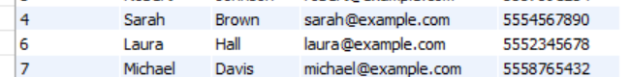

1. Rename the "paymentDate" column in the Payment table to "transactionDate".

ALTER TABLE Payment

CHANGE COLUMN paymentDate transactionDate DATE;

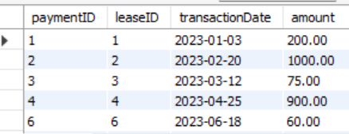

1. Find a specific customer by email.

SELECT * FROM Customer

WHERE email = 'janesmith@example.com';

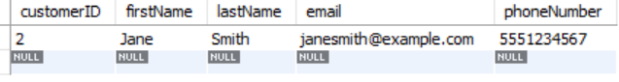

1. Get active leases for a specific customer.

SELECT * FROM Lease

WHERE customerID = 3

AND endDate >= CURDATE();

1. Find all payments made by a customer with a specific phone number.

SELECT P.paymentID, P.leaseID, P.amount, P.transactionDate

FROM Payment P

JOIN Lease L ON P.leaseID = L.leaseID

JOIN Customer C ON L.customerID = C.customerID

WHERE C.phoneNumber = '5557891234';

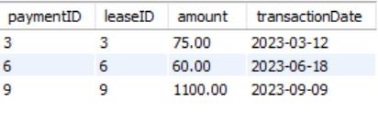

1. Calculate the average daily rate of all available cars.

SELECT AVG(dailyRate) AS avgDailyRate

FROM Vehicle

WHERE status = 'available';



1. Find the car with the highest daily rate.

SELECT * FROM Vehicle

ORDER BY dailyRate DESC

LIMIT 1;



1. Retrieve all cars leased by a specific customer.

SELECT V.vehicleID, V.make, V.model, V.year, V.dailyRate,

V.status, V.passengerCapacity, V.engineCapacity

FROM Vehicle V

JOIN Lease L ON V.vehicleID = L.vehicleID

WHERE L.customerID = 4;



1. Find the details of the most recent lease.

SELECT * FROM Lease

ORDER BY startDate DESC

LIMIT 1;



1. List all payments made in the year 2023.

SELECT * FROM Payment

WHERE YEAR(transactionDate) = 2023;

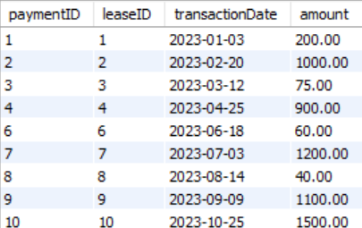

1. Retrieve customers who have not made any payments.

SELECT * FROM Customer

WHERE customerID NOT IN (SELECT DISTINCT customerID FROM Lease L

JOIN Payment P ON L.leaseID = P.leaseID);

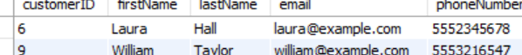

1. Retrieve Car Details and Their Total Payments.

SELECT V.vehicleID, V.make, V.model, SUM(P.amount) AS totalPayments

FROM Vehicle V

JOIN Lease L ON V.vehicleID = L.vehicleID

JOIN Payment P ON L.leaseID = P.leaseID

GROUP BY V.vehicleID, V.make, V.model;

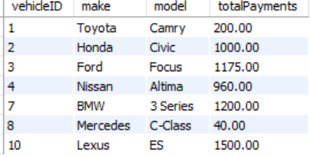

1. Calculate Total Payments for Each Customer

SELECT C.customerID, C.firstName, C.lastName, SUM(P.amount) AS totalPaid

FROM Customer C

JOIN Lease L ON C.customerID = L.customerID

JOIN Payment P ON L.leaseID = P.leaseID

GROUP BY C.customerID, C.firstName, C.lastName;

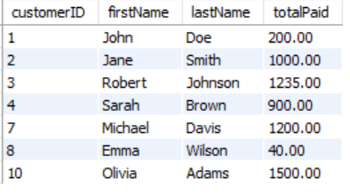

1. List Car Details for Each Lease.

SELECT L.leaseID, V.make, V.model, L.startDate, L.endDate

FROM Lease L

JOIN Vehicle V ON L.vehicleID = V.vehicleID;

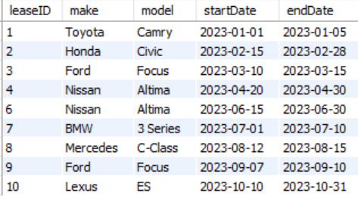

1. Retrieve Details of Active Leases with Customer and Car Information.

SELECT L.leaseID, C.firstName, C.lastName, V.make, V.model,

L.startDate, L.endDate

FROM Lease L

JOIN Customer C ON L.customerID = C.customerID

JOIN Vehicle V ON L.vehicleID = V.vehicleID

WHERE L.endDate >= '2023-06-01';

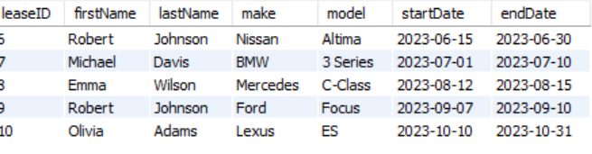

1. Find the Customer Who Has Spent the Most on Leases.

SELECT C.customerID, C.firstName, C.lastName, SUM(P.amount) AS totalSpent

FROM Customer C

JOIN Lease L ON C.customerID = L.customerID

JOIN Payment P ON L.leaseID = P.leaseID

GROUP BY C.customerID, C.firstName, C.lastName

ORDER BY totalSpent DESC

LIMIT 1;

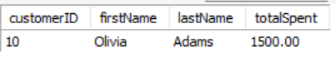

1. List All Cars with Their Current Lease Information.

SELECT V.vehicleID, V.make, V.model,

L.leaseID, L.startDate, L.endDate, C.firstName, C.lastName

FROM Vehicle V

LEFT JOIN Lease L ON V.vehicleID = L.vehicleID

LEFT JOIN Customer C ON L.customerID = C.customerID

WHERE L.endDate >= CURDATE() OR L.leaseID IS NULL;